English quotes
Arrange the words below to make well-known quotes about good deeds.
a. then if you can’t people feed one a hundred just feed.
__________________________________________________________
b. world be you change want the to see in the.

c. them only you look time at, is down when someone you are helping the up should
___________________________________________________________
d. men that is evil to prevail is for to for do nothing all required good
___________________________________________________________
Do you have similar quotes in your language?
Write them in a space provided.
a . _____________________________________________
b. ______________________________________________

- “If you can’t feed a hundred people, then just feed one.”
Mother Teresa
- “Be the change you want to see in the world.”
Ghandi
- “The only time you should look down at someone,
is when you are helping them up.”
Jesse Jackson
- “All that is required for evil to prevail is for good
men to do nothing.”
Edmund Burke

Possible answers:
Personal responsibility: punctual, courageous,
liable, duteous, mature, conscious, committed,
mindful;
Social responsibility: supportive, practical,
reliable, collaborative, effective, cross-functional,
collective, friendly, devoted;
Note: The above words can be used interchangeably
in both of the classification depending on the situation.

1.pull to one’s feet
2. give someone a fireman’s lift
3. help someone walk
4. give someone a piggy back
5. support someone under the arms
6. help someone lift up something
7. give someone a hand up
8. shelter someone under one’s umbrella
9. pull someone up

Listen to the dialogue and answer the questions.
1. The speakers introduce themselves a s__________ .
a. Freshmen carrying out the case survey for group project
b. Sophomore conducting one of her science projects.
c. Junior brainstorming ideas for her essay writing
d. Senior collecting data for her qualification paper
2. How long has the interviewee been settling in the area?
a. since she got married
b. since she gave birth to her second child
c. since she was born
d. since she changed her profession and did a location change
3. The interviewee said that the officials appointed the fine in amount of
_______________for the citizens dropping the garbage in the water.
a. eighteen thousand sums
b. seventy thousand sums
c. ninety thousand sums
d. sixty thousand sums
4. Write three differences mentioned by the interviewee comparing the river of today and 30 years ago.
a.
b.
c.
5. List three solutions suggested by the interviewee to the river case
a.
b.
c

4.
a. decrease in water level;
b. fishing and swimming
c. pollution;
5.
a. strict fining;
b. parent obligation;
c. community observation

Write adjectives and adverbs to characterize
personal and social responsibilities.

Personal responsibility

Social responsibilities

Reading

Read the story and tick the relevant passages
with the headings.

 | HEADINGS | A | B | C | D | E
1 | Asking for direction
2 | Identify
3 | Getting lost
4 | Finding the destination
5 | Schedule of shopping

SAMARITAN
My recent participation in a three-week Trainers’ Training programme at Norwich Institute for Language Education in the United Kingdom enabled me to discover much about English people. Staying at the host family of the Allens, I went deep to dive through cultural diversity observing how the English people meet their personal and social responsibilities. So, I have found it important to share some of the culture related cases. I can say that English people possess a strong sense of social committment.
Once I went shopping after my classes timed from 9 a.m. till 4 p.m. In the UK most shops are open till 5 p.m. and some are till 5:30 p.m. except Thursdays. Thursday is a special day when shops are open till 9 p.m. offering 20% discount for students. It was the very day when I completely forgot that the last bus departure to my destination was due to 7 p.m.. Arriving late at the bus stop I found the bus electronic time table blank. I hesitated to give a call to my hosts as they had already driven me twice after my social
programmes organized by the institute.
There, I decided, who am I, at the age of 30 getting lost in the street?! No way! I did have a map of my living area but I am not so good at reading the maps. So the best way is asking the direction. Iapproached the driver of other buses and they were extremely polite to give the detailed direction to my route, and finally, one offered me to give a lift explaining his direction to be a three bus stop away from Harvey Lane. Harvey Lane was my bus stop. Thanking I got out of the bus and found myself in a quite unknown place. Even I forgot the turnings to be taken instructed by the driver. I stood still for a moment when I suddenly saw a jogger – a young man on the other side of the street. The conversation went on as...
Durdona: Hellooooo, may I ask you for a moment, please!?
Cath: Oh, yes, wait, I am going across, wait there!
Durdona: Hello, I have got lost here. I wasn’t on time to catch my bus and had to take another bus to get at least the nearest place to my house, and now I have no idea how to reach.
Cath: Can you tell me your address?
Durdona: Yes, Telegraph Lane 9 at Harvey Lane.
C: Take it easy, I know that place. You should take the first tuning to the right just after that big supermarket ALDO, and then go straight having a 10 or maybe 15 - minute walk...
D: Oh, wait, I can’t get your point and the destination seems endless! Can you guide me to my house, please.
C: Actually, I am running to the other side. Well, yes, if you agree with my condition.
D: What condition?
C: I will take you if you run with me. Because, you know, while jogging once having sweated out the man shouldn’t cool off.
D: Yes, I agree, I will run with you, besides, I have comfortable shoes for running!
C: You think you can do?
D: Yes, surely.
C: Let’s start it then!....
D. On the way home seeing I was almost out of breath Cath let me slow down from time to time and finally we reached the target address. I felt blessed and was very grateful for having such people in our community. My hosts, listening all ears to my adventure how I found my way home, called Cath as Samaritan. I updated my English language vocabulary with ‘samaritan’ that means a person helping someone in difficulty.

Write definitions using the adjectives and adverbs
Personal responsibility is ______________________________________________________

Social responsibility is _________________________________________________________

Мое недавнее участие в трехнедельной программе подготовки тренеров в Норвичском институте языкового образования в Соединенном Королевстве позволило мне многое узнать об англичанах. Оставаясь в принимающей семье Алленов, я углубился в изучение культурного разнообразия, наблюдая, как англичане выполняют свои личные и социальные обязанности. Итак, я считаю важным поделиться некоторыми случаями, связанными с культурой. Я могу сказать, что англичане обладают сильным чувством социальной ответственности.
Однажды я пошла за покупками после занятий с 9 до 16 часов. В Великобритании большинство магазинов работают до 17:00. а некоторые до 5:30 вечера кроме четверга. Четверг - особый день, когда магазины открыты до 21:00. предлагает 20% скидку для студентов. Это был тот самый день, когда я полностью забыл, что последний отъезд автобуса к месту назначения должен был состояться в 7 часов вечера. Прибыв поздно на автобусной остановке, я обнаружил, что электронный график работы автобуса пуст. Я не решался позвонить своим хозяевам, так как они уже дважды подгоняли меня после моего общения
программы, организованные институтом.
Там я решил, кто я, в 30 лет заблудился на улице ?! Ни за что! У меня была карта моей жилой площади, но я не очень хорошо разбираюсь в картах. Так что лучше всего спрашивать направление. Я подошел к водителю других автобусов, и они были чрезвычайно вежливы, чтобы дать подробное направление моего маршрута, и, наконец, один из них предложил мне подвезти его, объясняя его направление в трех автобусных остановках от Харви-лейн. Харви Лейн был моей автобусной остановкой. Благодаря я вышел из автобуса и оказался в совершенно неизвестном месте. Даже я забыл повороты, которые должны быть проинструктированы водителем. Я остановился на мгновение, когда неожиданно увидел бегуна - молодого человека на другой стороне улицы. Разговор продолжился как ...

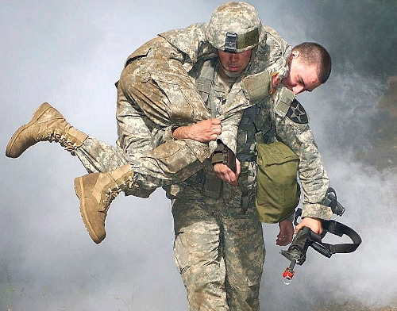

Speaking
Look at the people helping each other.
Match and write the appropriate action verbs from the box.
help someone lift up something
pull someone up
shelter someone under one’s umbrella
help someone walk
support someone under the arms
pull to one’s feet give someone a hand up
give someone a fireman’s lift

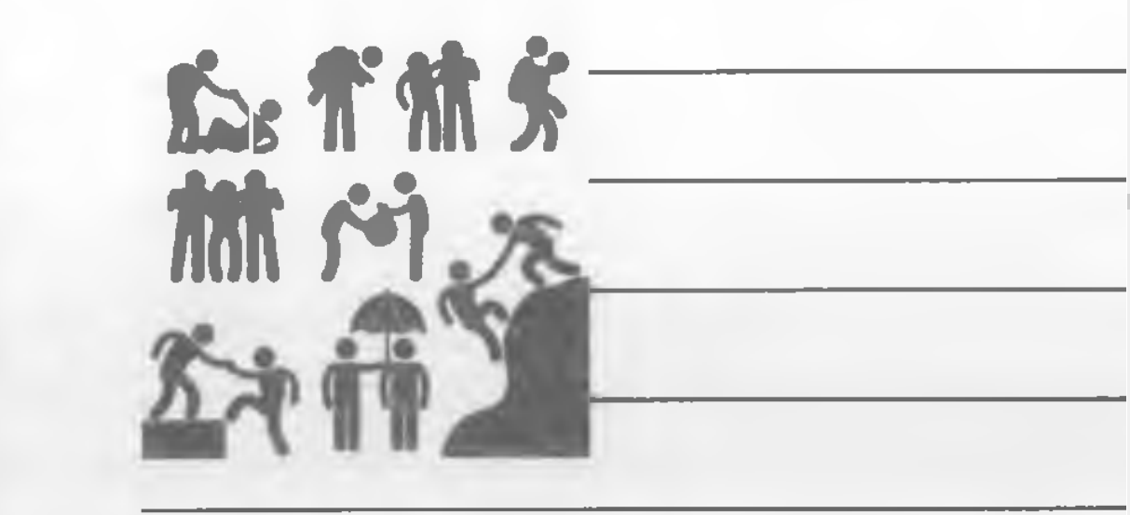

Think about the situations when you have used any of above listed verbs in action.
Write the situation in one sentence.
a. I pulled my friend up while climbing the mountain on our last journey.
b.
c.
d.
e.
f .

WRITING
Fill in the gaps using the verbs from the
box in an appropriate tense.
drive happen lead follow
receive get try start

I’m Akbar, a motor mechanic, and this is the story of something strange that____________ to me about five years ago. It was a freezing cold winter. One day I ___________ a call to assist a motorist whose car had broken down and was stuck in snow. As I ____________ to the place where the motorist stranded, I noticed that the snow was getting heavier. When I ___________ the phone call, I was sure I knew where the motorist was. But when I got there, I couldn’t see a car anywhere. I ___________ to call to my office, but my mobile’s battery was dead. I looked around, the snow had stopped, but it was lying thick on the ground. I got out of the car and___________ looking for some sign of the motorist. I looked down and saw some footprints in the snow. I began following them. They ___________ over a small bridge and across a park. It was freezing cold. I ______________ the footprints for about five minutes when I saw a phone box about one hundred meters away. I listened. I heard a noise.

HOMEWORK
List five characteristics you have and wish to improve in the spaces below. Then in the
second column, list five characteristics that you do not have but you wish you did.
MAN IN THE MIRROR
What kind of a person I am now:
__________________________________________________________________________________________________________________________________________________________________________________________________________________________________________________________________________________________________________________________________________________________________________________________________________________________________
What kind of a person I want to be:
__________________________________________________________________________________________________________________________________________________________________________________________________________________________________________________________________________________________________________________________________________________________________________________________________________________________________

Working for the community, such as volunteering, givingblood donations, and working at a food bank or animal shelter. Supporting issues that affect society, such as advocating political or social issues that can help others—for example, advocating for child labor laws, purchasing fair trade products, recycling.

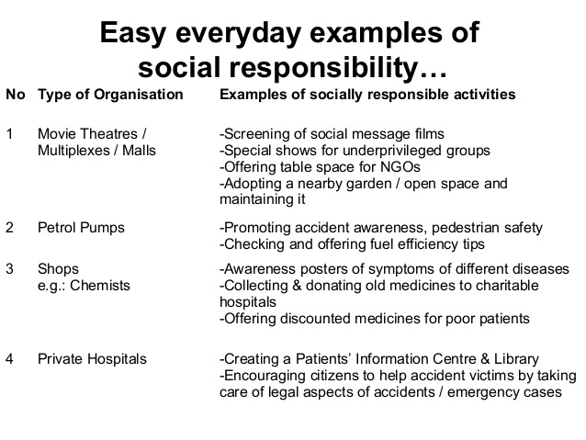

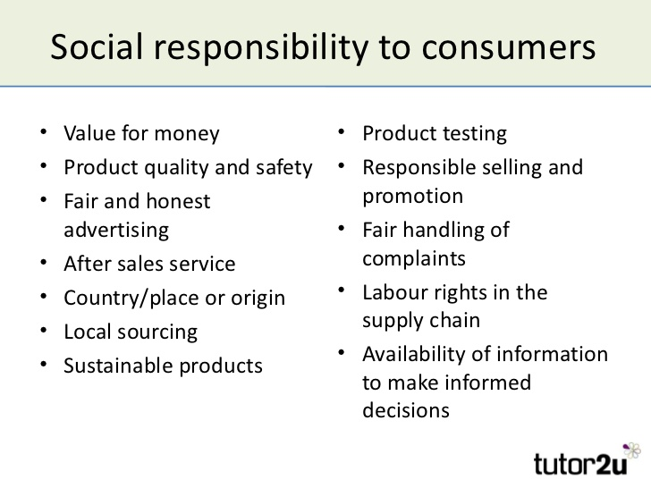

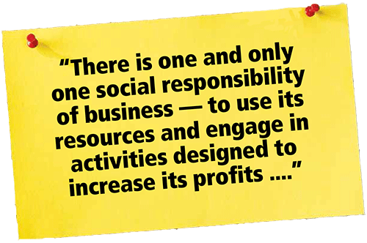

“Personal responsibility means taking responsibility for your actions, in other words, it’s being able to take care of one’s well-being without expecting or blaming others to do it for you,” as stated by QuintinBaker1 (2012). In another word, I am accountable for my actions to coincide with my goals because as a student, I’m expected to perform the assignments and study the materials to succeed in the course. Establishing and maintaining the positive relationship with my facilitator, I can communicate by the internet or by phone, and I know I can depend on the moderator to help me navigate through the course by asking questions if I do not understand the assignments.

