Lesson | Theme: “ Unit 14. The Coward’s lesson
The technology of teaching
Group | 202
The date of lesson | 15.12.2017
Time of the lesson: 2 hours | Students are about
The form of the lesson | Practical lesson Reading and writing
The plan of the practical lesson | 1. Introducing students with new theme  2. Introducing students with new words and combinations  3. Consolidate the new theme  4. Giving homework
The aim of the practical lesson: to explain the new theme, to develop speaking activities, to consolidate lexical and grammatical material
The pedagogical tasks:  - working on new words and combinations  - to develop speaking activities in English  - to give new information concerning to the speciality |  | The results of training  - they work on new words and combinations  - they practice speaking in English  - they get new information concerning to the specialty
The way of teaching |  | To work in small groups
The methods of teaching |  | Conversation, asking questions,press-formula,mind-map
The means of teaching |  | Handouts, materials prepared beforehand
The condition of teaching |  | Auditorial

The technological map of practical lesson

Steps and time of teaching | The meaning of activity
 | Teacher | Students
1.Introduction  (10 min) | 1.1. Introducing the theme, aim and results of the lesson and find importance and actuality of it.  1.2. Asking questions concerning new theme.  1.3. Announcing that the training should be operated by doing tasks dividing into small groups. | They listen  They answer the questions  They do the tasks
2. The main part of the lesson  (55 min) | 2.1. Dividing the students into 3 small groups and introducing the ways and the rules of working in groups  2.2. Each group is asked and demanded to answer the questions.  2.3. Small groups do exercises concerning to the theme  2.4. Leaders of the groups give answers to given questions. If it is necessary to clarify the answer the teacher could stop the leader and ask additional questions and present the discussing to the team.  2.5. Generalizing the information which are given on theme and concluding them.  2.6. Learning new words and phrases according to the topic.  2.7. In order to develop speaking activities the teacher asks to make dialogue using vocabulary notes.  2.8. Dividing into small groups act the prepared dialogue by role plays. | They are divided into small groups  They answer the questions  They work on tasks  Leaders of the groupsperformance the group’s answer  They make notices.  They work in groups and make dialogue.  They act the prepared dialogue in life.
3. The end of the lesson  (10 min ) | 3.1. Concluding the teaching activity  3.2 Analyzing the students’ activity and recommend to revise the details which couldn’t been progressed  3.3 Giving homework  3.4. Encouraging the active students and mark them generally | They listen  They revise the theme  They write the tasks  They will get marks
Theme “ The Cowards Lesson “
Camouflage is something used to hide people and things. The green and brown camouflage was best used for hiding in forests and jungles. To contemplate something means to think about it. Mark took a moment to contemplate the math problem before solving it. To contend with something means to struggle to overcome it. Stacy had to contend with a learning disability throughout high school. A cot is a small portable bed. At the camp, the boys’ cabin was lined with cots. To enlist means to join the military. In their final year at school, the students were asked to enlist in the military. A frontier is a border between two regions or countries. A fence was built along the frontier where the river curved. A handbook is an item that gives specific information or instructions. If you look at the handbook, it will tell you which wires to connect to the TV. If someone is hesitant, then they are not sure or slow in acting or speaking. Though he knew the answer, he was hesitant to say it because he might be wrong. If something is lush, then it is full of a variety of large, healthy plants. The lush jungle was filled with plants, trees, and vines. Marrow is the soft substance in the center of bones. Dissolved marrow is a common ingredient in soups. An outfit is a set of clothes worn together, often for a certain job or event. Kelly’s new outfit made her look so glamourous. A paw is an animal’s foot that has claws or soft bottoms. The kitten cleaned its paws with its tongue. To quiver means to tremble or shake. The flame on the candle quivered whenever someone opened or closed a door. If something or someone is splendid, then they are very good. From his head down to his shoes, his clothes looked splendid. To stray means to go in a wrong direction and often become lost. He found himself lost because he had strayed from the tour group. If something is substantial, then it is of great importance, size, or value. The bank said that he owed it a substantial amount of money. A torch is a stick with one end on fire that can be carried in order to give tight. He grabbed a piece of wood and stuck it in the fire in order to make a torch. A tract is a large area of land. On the other side of the mountains was a long tract of forest. A vigil is a period of watchful attention at night for a specific purpose. He had a vigil in front of the tomb for three days. If someone is weary, then they are tired. jane was weary after a long day of work.

The Coward’s Lesson

Tom was easily frightened. He enlisted in the army because he thought the military would teach him courage. And though he needed courage, he never imagined how he would learn it. During a march across a tract of wilderness near his country’s frontier, Tom strayed from his squad. He had stopped to gaze at a splendid view of a lush valley. When he turned around, his squad was gone. He searched for them, but because their outfits had camouflage, he couldn’t find them. It was getting dark, and Tom grew weary. All he had was a knife, a boomerang, and his handbook. He made a camp for the night. It was cold, and the ground was hard. He wished he had his cot and a blanket. Instead, he made a fire, wrapped himself tightly in his jacket, and fell asleep. A loud noise roused him from his sleep. “What was that?” he wondered. Then he noticed it. An animal of substantial size had left a print from its paw in the dirt. He sat closer to the fire and looked into the darkness. He imagined a large beast jumping from the gloom and attacking him. He shook so much from fear that it felt like the marrow in his bones quivered. Tom contemplated many different plans. He was hesitant to act. He decided to stay by the fire, but during his vigil, he heard more noises. He couldn’t contend with his fear any longer. He knew what he had to do. He made a torch and followed the prints. He heard a twig snap very close ahead, but he bravely went on. Seconds later, he discovered what had scared him. It was only a kangaroo. Tom went back to his camp and slept. In the morning, he found his squad. He had finally learned courage. He learned that he had to confront his fear in order to conquer it.

How a Coward Changed the World - Lessons in Brave Leadership From the Man Called Gandhi
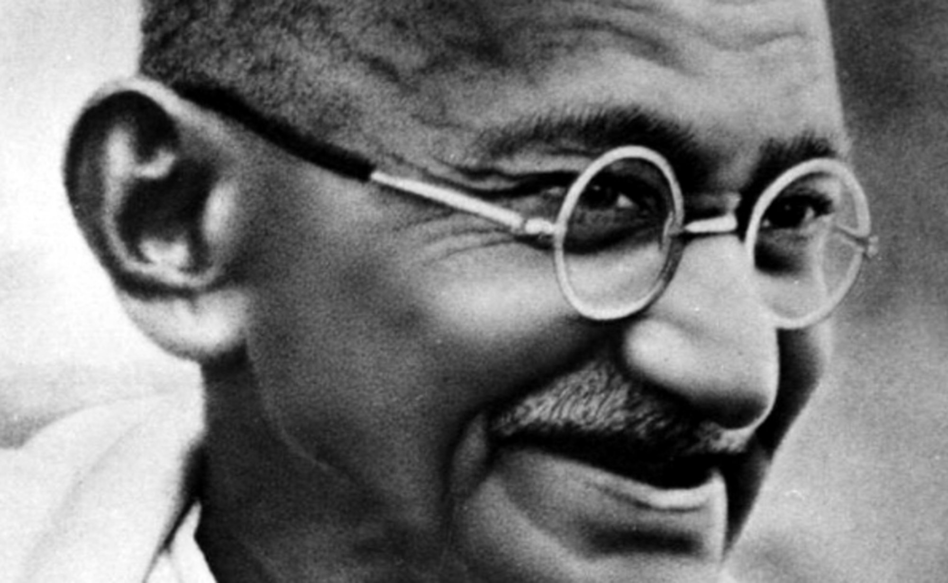
He ran home from school to avoid speaking to people, had low self-esteem, and once contemplated suicide.
Mohandas Gandhi began life viewing himself as a coward, afraid of almost everything, unwilling to take a stand and preferring to live in the shadows.
But the terminally shy Gandhi would become enraged at the injustices of the world, see that others were doing little about it, and transform himself into one of the world's great ambassadors of peace.
The incredible transformation of the young Gandhi, rarely studied, is revealed here, showing a clear path for how all of us today can rise up and make a difference in our lives and in this troubled world.
“Strength does not come from physical capacity. It comes from an indomitable will.”
Gandhi came from a family of vegetarians and as a boy was told that westerners were bigger and stronger because they ate meat. Wanting to be physically powerful, the boy Gandhi became a thief and began stealing to pay for his meat, which he secretly ate away from home - deceiving his family. Gandhi admitted his wrongdoing to his father, but also noticed that no matter how much meat he consumed, he was still small. Strength, he concluded later in life, is not about brute force. It's about discipline, focus and a strong will. Today, we underestimate our own ability to influence outcomes. The world is too enormous, we believe. Gandhi's determination inspired millions. We too can help others by setting an example with our will power.
“A coward is incapable of exhibiting love; it is the prerogative of the brave.”
Speaking about himself as a young person, Gandhi said, "I was a coward. I used to be haunted by the fear of thieves, ghosts and serpents. I did not dare to stir out of doors at night. Darkness was a terror to me." (Quote from Gandhi's autobiography "The story of my experiments with truth" Chapter 6).
His fear was so paralyzing that he was incapable of loving himself and others. He would come to realize that bravery, devotion to family, and fighting for a cause - were expressions of love. Today, are we too afraid to express love? Has the world's uncertainty and brutality beaten love out of us? Or can we step out of our comfort zone, be brave, and show the power of a loving heart and mind?
“My creed of nonviolence is an extremely active force. It has no room for cowardice or even weakness.”
In his time, Gandhi was highly criticized for his movement of non-violence. Yet, he viewed the refusal to take up arms as a sign of strength, not weakness. The idea of peaceful demonstration is credited to Gandhi who changed the fate of a nation without firing a shot. Today, it takes strength to be kind in a world that easily succumbs to violence. We have the power to show our co-workers, friends and family that talking is better than fighting.
Gandhi believed that manual labor was an honorable way to make a living. To assert independence, he advocated all Indians use the spinning wheel to make their own clothes, rather than depend on British imports. This photo of Gandhi spinning was taken just a few months before his tragic assassination in 1948 at the hands of a fellow Hindu.
It was perhaps because Gandhi saw himself as a coward in his early life that he became so against cowardice in his battle to fight injustice.
It is not well known, but even Gandhi believed in the use of violence when confronted with evil and given no other choice. In his words; "He who cannot protect himself or his nearest and dearest or their honour by non-violently facing death may and ought to do so by violently dealing with the oppressor."
Cowardice, above all else, in Gandhi's mind, was the greatest sin. A coward, he angrily said, "does not deserve to be a member of a society of men and women.”
Today, as leaders in business, and self-leaders, let us ask ourselves whether we are being cowards or brave, in our decisions. Choosing to be brave means living our convictions and dying without regret.
Cowardice can be removed when we see things that just aren't right. It was that way with Gandhi.
The year was 1893 when the 24 year old Gandhi travelled from his birthplace of India to try a court case in South Africa. It was there, as a young lawyer, that Gandhi chose bravery over cowardice.
In the courtroom, the judge told Gandhi to remove the turban he was wearing. Gandhi defied the judge, saying that removing the headgear was a sign of disrespect in India.
But Gandhi's shock at mistreatment, and his decision to fight it, escalated when he took a train ride as part of his case research. He proudly purchased a first class ticket but was told by the train conductor that because he was Indian, he had to travel in a third-class compartment.
Of course, Gandhi refused. As a result, he was kicked off the train. Alone, dejected and with nowhere else to go, he spent the night freezing in the train station.
He thought seriously about just going back to India. Instead, at that moment, in the quiet of the night, he decided to fight racial oppression.
The shy, afraid coward was gone. A new person was born, renewed by a life purpose, willing to starve himself and go to jail, aware that others may want to kill him for his beliefs, and determined to make a difference.
Bravery would become the Gandhi trademark.
Sorely lacking today, his legacy of single-minded focus is nudging us all to open the door and step out of our comfort zone.
Despite being what some would argue, the greatest ambassador of peace the world has ever known, Gandhi was never awarded the Nobel Peace prize, even though he was nominated five times. The peace prize committee has admitted that was a mistake.
ПоделитьсяПоделиться вакансией на должность «How a Coward Changed the World - Lessons in Brave Leadership From the Man Called Gandhi»

